Families of the Starting Person

Lucy HART
1. Lucy HART was born on Sunday, 21st January 1787, in Latchingdon, Essex, England.[, ] She was the daughter of Isaac HART (2) and Mary BECKFORD (3).
Lucy was baptized in Latchingdon on 21st January 1787.[] She was christened in Latchingdon on 21st January 1787.[3] Lucy died in Rochford on 6th November 1864, at the age of 77.[, 3]
More facts and events for Lucy HART:
Residence: | 1851 | Rayleigh, Essex, England[2]
 |  | Relationship: Wife
Residence: | 1861 | Rayleigh, Essex, England[1]
 |  | Relationship: Wife
Residence: |  | Mayland, Essex, England[]

Marriages with William GARPIN and William ATKINS (Page 7) are known.

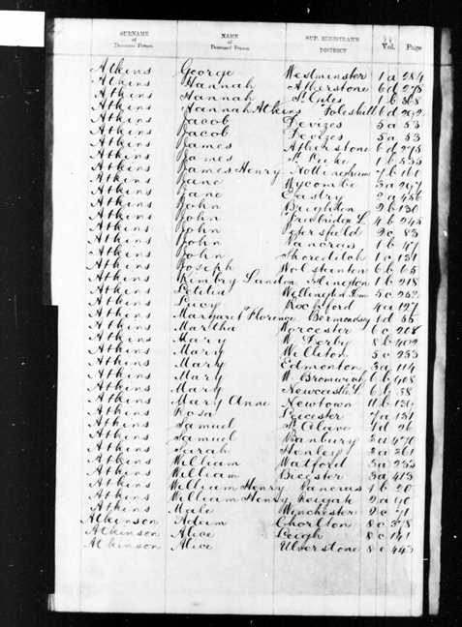
Figure 1: England & Wales, Civil Registration Death Index, 1837-1915

Family of Lucy HART and William GARPIN
 |  |  |  |  |  |  |  |  |  |  |  |  |  |  |  | Jacob |  |  |  | Mary |  |  |  | John |  |  |  | Mary
 |  |  |  |  |  |  |  |  |  |  |  |  |  |  |  | HART |  |  |  | CHENERY |  |  |  | BEARD
 |  |  |  |  |  |  |  |  |  |  |  |  |  |  |  | 1711–1750 |  |  |  | 1715–
 |  |  |  |  |  |  |  |  |  |  |  |  |  |  |  |  | Isaac |  |  |  |  |  |  |  | Mary
 |  |  |  |  |  |  |  |  |  |  |  |  |  |  |  |  | HART |  |  |  |  |  |  |  | BECKFORD
 |  |  |  |  |  |  |  |  |  |  |  |  |  |  |  |  | 1746–>1788 |  |  |  |  |  |  |  | 1747–
 |  |  |  |  | William |  |  |  |  |  |  |  |  |  |  |  |  |  |  |  | Lucy
 |  |  |  |  | GARPIN |  |  |  |  |  |  |  |  |  |  |  |  |  |  |  | HART
 |  |  |  |  | 1780–1810 |  |  |  |  |  |  |  |  |  |  |  |  |  |  |  | 1787–1864
 |  |  |  |  |  |  |  |  | Marriage: 1803
 |  |  |  |  |  |  |  | Ruth |  |  |  | Mary |  |  |  | James |  |  |  | Robert
 |  |  |  |  |  |  |  | GARPIN |  |  |  | GARPIN |  |  |  | GARPIN |  |  |  | GARPIN
 |  |  |  |  |  |  |  | 1804–1880 |  |  |  | 1806–1884 |  |  |  | 1808– |  |  |  | 1809–1842

Here are the details about Lucy HART's first marriage with William GARPIN. You can read more about Lucy on page 5.
Lucy HART married William GARPIN on Tuesday, 2nd August 1803, in Maryland.[, 5] They had four children: Ruth (1804–1880), Mary (1806–1884), James (1808–) and Robert (1809–1842).
William GARPIN was born in 1780. William reached 30 years of age and died in 1810.
Children of Lucy HART and William GARPIN:
f I. Ruth GARPIN was born in 1804. She died in 1880 at the age of 76.
f II. Mary GARPIN was born in 1806. She died in 1884 at the age of 78.
m III. James GARPIN was born in 1808.
m IV. Robert GARPIN was born in 1809. He died in 1842 at the age of 33.

Family of Lucy HART and William ATKINS
John |  |  |  |  |  | Elizazbeth |  |  |  |  |  |  |  |  |  |  |  |  |  |  |  |  |  | Jacob |  |  |  |  |  | Mary |  |  |  |  |  | John |  |  |  |  |  | Mary
ATKINS |  |  |  |  |  | SIMKIN |  |  |  |  |  |  |  |  |  |  |  |  |  |  |  |  |  | HART |  |  |  |  |  | CHENERY |  |  |  |  |  | BEARD
1728–1775 |  |  |  |  |  | 1731– |  |  |  |  |  |  |  |  |  |  |  |  |  |  |  |  |  | 1711–1750 |  |  |  |  |  | 1715–
 |  | James |  |  |  |  |  |  |  |  |  |  |  | Mary Ann |  |  |  |  |  |  |  |  |  |  |  | Isaac |  |  |  |  |  |  |  |  |  |  |  | Mary
 |  | ATKINS |  |  |  |  |  |  |  |  |  |  |  | HOGG |  |  |  |  |  |  |  |  |  |  |  | HART |  |  |  |  |  |  |  |  |  |  |  | BECKFORD
 |  | 1765– |  |  |  |  |  |  |  |  |  |  |  | 1766– |  |  |  |  |  |  |  |  |  |  |  | 1746–>1788 |  |  |  |  |  |  |  |  |  |  |  | 1747–
 |  |  |  |  |  |  |  | William |  |  |  |  |  |  |  |  |  |  |  |  |  |  |  |  |  |  |  |  |  |  |  | Lucy
 |  |  |  |  |  |  |  | ATKINS |  |  |  |  |  |  |  |  |  |  |  |  |  |  |  |  |  |  |  |  |  |  |  | HART
 |  |  |  |  |  |  |  | 1791–1872 |  |  |  |  |  |  |  |  |  |  |  |  |  |  |  |  |  |  |  |  |  |  |  | 1787–1864
 |  |  |  |  |  |  |  |  |  |  |  |  |  | Marriage: 1811
 |  |  | James |  |  |  |  |  | Mary Ann |  |  |  |  |  | William |  |  |  |  |  | Eliza |  |  |  |  |  | Susan |  |  |  |  |  | Charlotte |  |  |  |  |  | Isaac Reuben
 |  |  | ATKINS |  |  |  |  |  | ATKINS |  |  |  |  |  | ATKINS |  |  |  |  |  | ATKINS |  |  |  |  |  | ATKINS |  |  |  |  |  | ATKINS |  |  |  |  |  | ATKINS
 |  |  | 1814–1844 |  |  |  |  |  | 1815–1906 |  |  |  |  |  | 1816– |  |  |  |  |  | 1821– |  |  |  |  |  | 1825– |  |  |  |  |  | 1826–1840 |  |  |  |  |  | 1828–1900
 |  |  |  |  |  |  |  |  | 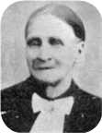

Here are the details about Lucy HART's second marriage with William ATKINS. You can read more about Lucy on page 5.
Lucy HART married William ATKINS on Monday, 27th May 1811, in North Benfleet.[, 7] They had seven children: James (1814–1844), Mary (1815–1906), William (1816–), Eliza (1821–), Susan (1825–), Charlotte (1826–1840) and Isaac (1828–1900).
William ATKINS was born in Downham, Sussex, in 1791.[1, 2, 4] He was the son of James ATKINS and Mary Ann HOGG.
William was baptized in Downham, Essex, on 20th February 1791.[3] He was christened in Downham on 20th February 1791.[3] William reached 81 years of age and died in Holborn, Middlesex, in January 1872.[4]
More facts and events for William ATKINS:
Residence: | 1851 | Rayleigh, Essex, England[2]
 |  | Relationship: Head
Residence: | 1861 | Rayleigh, Essex, England[1]
 |  | Relationship: Head

Children of Lucy HART and William ATKINS:
m I. James ATKINS was born in Hockley on 14th February 1814.[3] He was baptized in Hockley on 24th July 1814.[3, ] James died in Hockley on 12th April 1844, at the age of 30.[3]
f II. Mary Ann ATKINS was born in Hockley on 20th December 1815.[, , , , , , , , , , , , , 3] She was baptized in Hockley on 11th February 1816.[3] She was buried in Liberty, Bear Lake, ID, in 1906.[12, 19, 21, 3] | Mary
Mary Ann died at Alternative death place - Liberty, Bear Lake, Idaho in Cardston, Alberta, Canada, on 13th October 1906, at the age of 90.[12, 19, 20, 21, 3]
More facts and events for Mary Ann ATKINS:
Residence: | 1841 | Rayleigh, Essex, England[18]
Residence: | 1851 | Chelmsford, Essex, England[9, 14]
 |  | Relationship: Wife
Residence: | 1861 | Hockley, Essex, England[13]
 |  | Relationship: Wife
Residence: | 1862 | Liberty, Bear Lake, Idaho, USA
Residence: | 1870 | Hyde Park, Cache, Utah, USA[15]
 |  | Post Office: Hyde Park
Residence: | 1881 | Chelmsford, Essex, England[11]
 |  | Marital Status: Widow; Relationship to Head: Mother in Law
Residence: | 1891 | Burnham, Essex, England[10]
 |  | Relation to Head of House: Head
Residence: | 1901 | Cardston, Alberta, The Territories, Canada[16]
 |  | Marital Status: Widowed; Relation to Head of House: Mother
Residence: | 1906 | Town of Cardston, Alberta, Alberta, Canada[17]
 |  | Relation to Head of House: Mother; Marital Status: Widowed
Residence: |  | Utah, USA[]
Residence: |  | Salt Lake City, Salt Lake, UT (1862) Liberty, Bear Lake, ID (1864)[12]

At the age of 18, Mary Ann ATKINS married William HYMAS on Monday, 6th January 1834, in Rayleigh, Essex, England, when he was 27 years old.[12, 3, 12] | William
They had fifteen children: George (1834–1907), William (1837–1916), John (1839–1917), Sarah (1841–1929), Eliza (1842–1902), Susan (1844–?), Benjamin (1846–1925), Hannah (1847–), Reuben (1847–1925), James (1849–1908), Matilda (1850–1922), Mary (1851–1922), Clara (1855–1922), Agnes (1855–) and David (1857–). William HYMAS was born in Rayleigh on Saturday, 26th July 1806.[, , , , 3, 14, 13, 20, 12]He was the son of Edward HYMAS and Sarah HOWLETT.
William immigrated to New York, New York, USA, on 22nd May 1861. He was buried in Liberty, Bear Lake County, in May 1889.[24, 3, 12]William reached 82 years of age and died in Liberty, Bear Lake, Idaho, on 7th May 1889.[24, 3, 20, 12]
Mary Ann ATKINS married John Anthony WOOLF in 1872. John Anthony WOOLF was born in 1805.
John Anthony reached 76 years of age and died in 1881.
m III. William ATKINS was born in 1816.
f IV. Eliza ATKINS was born in 1821.
f V. Susan ATKINS was born in 1825.
f VI. Charlotte ATKINS was born in Hockley on 8th March 1826.[3] She died on 21st November 1840, at the age of 14.
m VII. Isaac Reuben ATKINS was born in Hockley on 22nd April 1828.[, 4, ] He died in Middlesex on 1st November 1900, at the age of 72.[27, 4, ] Isaac Reuben was buried in St Pancras Parish Chapel on 6th November 1900.[27] His estate was probated on 16th November 1900, in London.
More facts and events for Isaac Reuben ATKINS:
Residence: | 1871 | St Pancras, London, England[28]
 |  | Relationship: Head

Isaac Reuben ATKINS married Charlotte TAYLOR in 1857. Charlotte TAYLOR was born in 1831.

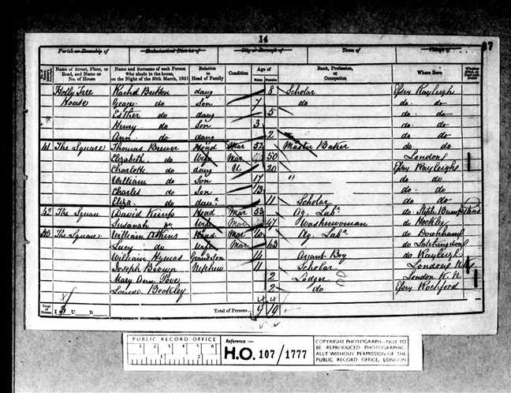  Figure 2: 1851 England Census |  | 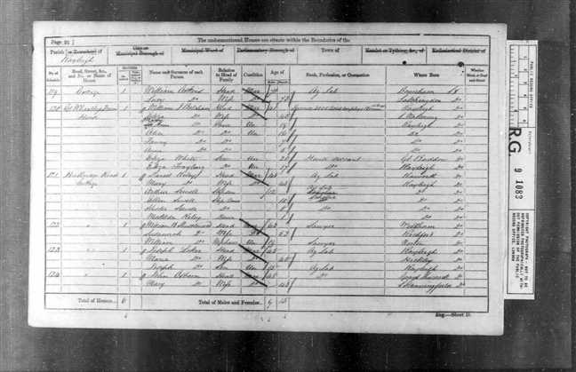  Figure 3: 1861 England Census

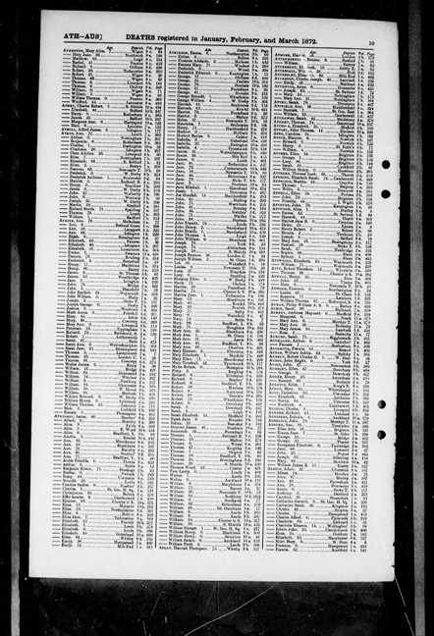
Figure 4: England & Wales, Civil Registration Death Index, 1837-1915

Families of her Ancestors

1st Generation

Family of Isaac HART and Mary BECKFORD
Henry |  |  |  | Elizabeth
HART |  |  |  | HALES
1678–? |  |  |  | 1682–1765
 | Jacob |  |  |  |  |  |  |  | Mary |  |  |  |  |  |  |  | John |  |  |  |  |  |  |  | Mary
 | HART |  |  |  |  |  |  |  | CHENERY |  |  |  |  |  |  |  | BEARD
 | 1711–1750 |  |  |  |  |  |  |  | 1715–
 |  |  |  |  | Isaac |  |  |  |  |  |  |  |  |  |  |  |  |  |  |  | Mary
 |  |  |  |  | HART |  |  |  |  |  |  |  |  |  |  |  |  |  |  |  | BECKFORD
 |  |  |  |  | 1746–>1788 |  |  |  |  |  |  |  |  |  |  |  |  |  |  |  | 1747–
 |  |  |  |  |  |  |  |  | Marriage: 1770
 |  |  |  | Isaac |  |  |  | William |  |  |  | Abraham |  |  |  | Daniel |  |  |  | Sarah |  |  |  | Lucy
 |  |  |  | HART |  |  |  | HART |  |  |  | HART |  |  |  | HART |  |  |  | HART |  |  |  | HART
 |  |  |  | 1769– |  |  |  | 1771–1824 |  |  |  | 1777– |  |  |  | 1779– |  |  |  | 1783–1823 |  |  |  | 1787–1864

2. Isaac HART was born on 23rd February 1746, in Latchington, Essex, England.[] He was the son of Jacob HART (4) and Mary CHENERY (5).
Isaac was baptized in Latchingdon on 25th May 1746.[30] He was christened in Latchington on 25th May 1746.[30] Isaac died in Latchington after 1788.
3. Isaac married Mary BECKFORD on Saturday, 8th December 1770, in Latchingdon.[30, 30] They had six children: Isaac (1769–), William (1771–1824), Abraham (1777–), Daniel (1779–), Sarah (1783–1823) and Lucy (1787–1864).
Mary BECKFORD was born in Latchingdon in 1747.[30] She was the daughter of John BEARD (6) and Mary (7).
Mary is deceased.
Children of Isaac HART and Mary BECKFORD:
m I. Isaac HART was born in Latchingdon in 1769.
More facts and events for Isaac HART:
Residence: |  | Snoreham, Essex, England[]

Isaac HART married Martha BEARD on Thursday, 2nd December 1790, in Latchingdon.[31, 31]They had one son: Isaac (1791–).
Martha BEARD was born in Latchingdon in 1762. Martha reached 48 years of age and died on 27th February 1810.
Isaac HART married Dinah TAYLOR in 1810. Dinah TAYLOR was born in Burnham on Crouch in 1791.
m II. William HART was born in Latchingdon on 28th June 1771.[] He died in Latchingdon in 1824 at the age of 52.[32] William was buried in Asheldham on 4th July 1824.[32]
William HART married Martha RICE. They had two sons: Stephen (1798–1874) and Abraham.
Martha RICE was born in 1773.[32] She was the daughter of James RICE and Sarah READ.
Martha was baptized in Saint Matthew,Ipswich,Suffolk,England, on 7th March 1773.[] Martha reached 52 years of age and died in 1825.[32] She was buried in Asheldham, Essex, England, on 10th August 1825.[32]
m III. Abraham HART was born in Latchingdon on 28th August 1777.
Abraham HART married Sarah MARVIN in 1797. Sarah MARVIN was born in 1778.
Abraham HART married Mary INNEFER in 1803.
Abraham HART married Susannah RUSH in 1814. Susannah RUSH was born in 1786.
m IV. Daniel HART was born in Latchingdon in 1779.
f V. Sarah HART was born in Latchingdon on 14th January 1783. She was baptized in Chelmsford on 14th September 1783.[33] Sarah died in Latchingdon on 14th December 1823, at the age of 40.
Sarah HART married John HUMPHREYS in 1801. They had six children: James (1802–), Dorcas (1803–), William (1806–), John (1807–1808), Mary (1809–) and Henry (1815–1886).
John HUMPHREYS was born in 1770. John reached 87 years of age and died in 1857.
+ 1 f VI. Lucy HART was born in Latchingdon on 21st January 1787.[, ] She died in Rochford on 6th November 1864, at the age of 77.[, 30]

2nd Generation

Family of Jacob HART and Mary CHENERY
 | Henry |  |  |  |  |  |  |  | Elizabeth
 | HART |  |  |  |  |  |  |  | HALES
 | 1678–? |  |  |  |  |  |  |  | 1682–1765
 |  |  |  |  | Jacob |  |  |  |  |  |  |  |  |  |  |  |  |  |  |  | Mary
 |  |  |  |  | HART |  |  |  |  |  |  |  |  |  |  |  |  |  |  |  | CHENERY
 |  |  |  |  | 1711–1750 |  |  |  |  |  |  |  |  |  |  |  |  |  |  |  | 1715–
 |  |  |  |  |  |  |  |  | Marriage: 1736
Jacob |  |  |  | Mary |  |  |  | Sarah |  |  |  | Elizabeth |  |  |  | Jacob |  |  |  | Isaac |  |  |  | Priscilla |  |  |  | Sarah
HART |  |  |  | HART |  |  |  | HART |  |  |  | HART |  |  |  | HART |  |  |  | HART |  |  |  | HART |  |  |  | HART
1737–1738 |  |  |  | 1738–1741 |  |  |  | 1739–1741 |  |  |  | 1743– |  |  |  | 1746–1799 |  |  |  | 1746–>1788 |  |  |  | 1747–1748 |  |  |  | 1749–1749

4. Jacob HART was born in 1711 in Latchingdon, Essex, England.[] He was the son of Henry HART (8) and Elizabeth HALES (9).
Jacob died in Latchingdon on 10th May 1750, at the age of 39.[37]
5. Jacob married Mary CHENERY on 21st July 1736, in Latchingdon.[37, 37] They had eight children: Jacob (1737–1738), Mary (1738–1741), Sarah (1739–1741), Elizabeth (1743–), Jacob (1746–1799), Isaac (1746–>1788), Priscilla (1747–1748) and Sarah (1749–1749).
Mary CHENERY was born in Latchingdon in 1715.[37] Mary was baptized in Luddenham, Kent, on 12th February 1715.[]
Children of Jacob HART and Mary CHENERY:
m I. Jacob HART was born in Latchingdon in 1737. He died in Latchingdon on 2nd July 1738, at the age of 1.
f II. Mary HART was born in Latchingdon in 1738. She died in Latchingdon in 1741 at the age of 3.
f III. Sarah HART was born in Latchingdon in 1739. She died in Latchingdon in 1741 at the age of 2.
f IV. Elizabeth HART was born in Latchingdon in 1743.
Elizabeth HART married Abraham SHAVE in 1763. They had one son: Abraham (1765–).
Abraham SHAVE was born in 1734. He was the son of Jacob SHAVE and Susanna UNKNOWN.
Abraham was baptized in Great Waldingfield,Suffolk,England, on 25th June 1734.[38]
m V. Jacob HART was born in Latchingdon in 1746. He died in Latchingdon in 1799 at the age of 53.
+ 2 m VI. Isaac HART was born in Latchington on 23rd February 1746.[37] He died in Latchington after 1788.
f VII. Priscilla HART was born in Latchingdon on 30th December 1747. She died in Latchingdon on 11th October 1748.
f VIII. Sarah HART was born in 1749. She died in 1749.

Family of John BEARD and Mary
 |  |  |  |  |  |  |  | John |  |  |  |  |  |  |  |  |  |  |  |  |  |  |  |  |  |  |  |  |  |  |  | Mary
 |  |  |  |  |  |  |  | BEARD
 |  |  |  |  |  |  |  |  |  |  |  |  |  | Married
 |  |  |  |  |  |  |  |  |  |  |  |  |  |  |  |  |  |  |  |  | Mary
 |  |  |  |  |  |  |  |  |  |  |  |  |  |  |  |  |  |  |  |  | BECKFORD
 |  |  |  |  |  |  |  |  |  |  |  |  |  |  |  |  |  |  |  |  | 1747–

6. John BEARD.
7. He married Mary. They have one daughter: Mary (1747–).
Daughter of John BEARD and Mary:
+ 3 f I. Mary BECKFORD was born in Latchingdon, Essex, England, in 1747.[] She is deceased.

3rd Generation

Family of Henry HART and Elizabeth HALES
 |  |  |  |  |  |  |  | Henry |  |  |  |  |  |  |  |  |  |  |  |  |  |  |  |  |  |  |  |  |  |  |  | Elizabeth
 |  |  |  |  |  |  |  | HART |  |  |  |  |  |  |  |  |  |  |  |  |  |  |  |  |  |  |  |  |  |  |  | HALES
 |  |  |  |  |  |  |  | 1678–? |  |  |  |  |  |  |  |  |  |  |  |  |  |  |  |  |  |  |  |  |  |  |  | 1682–1765
 |  |  |  |  |  |  |  |  |  |  |  |  |  | Marriage: 1708
 |  |  |  |  |  |  |  |  |  |  |  |  |  |  |  |  |  |  |  |  | Jacob
 |  |  |  |  |  |  |  |  |  |  |  |  |  |  |  |  |  |  |  |  | HART
 |  |  |  |  |  |  |  |  |  |  |  |  |  |  |  |  |  |  |  |  | 1711–1750

8. Henry HART was born in 1678 in Hatfield Peverel, Essex, England. He died in Hatfield Peverel.
9. Henry married Elizabeth HALES in 1708 at Henry was widowed in Boreham.[] They had one son: Jacob (1711–1750).
Elizabeth HALES was born in 1682.[] Elizabeth reached 83 years of age and died in 1765.[41] She was buried in Lowestoft, St Margaret, Suffolk, on 20th October 1765.[41]
Son of Henry HART and Elizabeth HALES:
+ 4 m I. Jacob HART was born in Latchingdon in 1711.[] He died in Latchingdon on 10th May 1750, at the age of 39.[42]

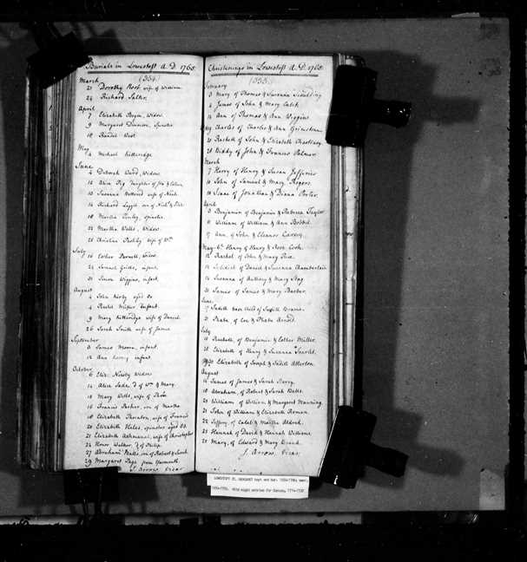
Figure 5: Norfolk, England, Church of England Baptism, Marriages, and Burials, 1535-1812

Ancestry.com, 1861 England Census (Provo, UT, USA, Ancestry.com Operations Inc, 2005), Ancestry.com, Class: RG 9; Piece: 1083; Folio: 16; Page: 26; GSU roll: 542750.
Ancestry.com, 1851 England Census (Provo, UT, USA, Ancestry.com Operations Inc, 2005), Ancestry.com, Class: HO107; Piece: 1777; Folio: 97; Page: 14; GSU roll: 207424.
Heritage Consulting, Millennium File (Provo, UT, USA, Ancestry.com Operations Inc, 2003), Ancestry.com.
FreeBMD, England & Wales, Civil Registration Death Index, 1837-1915 (Provo, UT, USA, Ancestry.com Operations Inc, 2006), Ancestry.com.
Ancestry.com, England, Select Marriages, 1538–1973 (Provo, UT, USA, Ancestry.com Operations, Inc., 2014), Ancestry.com.
Ancestry.com, England & Wales Marriages, 1538-1988 (Provo, UT, USA, Ancestry.com Operations Inc, 2008), Ancestry.com, Place: Mayland, Essex, England; Collection: ; Marriage Transcripts; Date Range: 1802 - 1806; Film Number: 990406.
Ancestry.com, Essex, England, Select Church of England Parish Registers, 1518-1960 (Provo, UT, USA, Ancestry.com Operations, Inc., 2014), Ancestry.com.
Ancestry.com, England, Select Births and Christenings, 1538-1975 (Provo, UT, USA, Ancestry.com Operations, Inc., 2014), Ancestry.com.
Ancestry.com, 1851 England Census (Provo, UT, USA, Ancestry.com Operations Inc, 2005), Ancestry.com, Class: HO107; Piece: 1775; Folio: 504; Page: 22; GSU roll: 207422.
Ancestry.com, 1891 England Census (Provo, UT, USA, Ancestry.com Operations Inc, 2005), Ancestry.com, Class: RG12; Piece: 1395; Folio: 36; Page: 24; GSU roll: 6096505.
Ancestry.com and The Church of Jesus Christ of Latter-day Saints, 1881 England Census (Provo, UT, USA, Ancestry.com Operations Inc, 2004), Ancestry.com, Class: RG11; Piece: 1763; Folio: 95; Page: 18; GSU roll: 1341424.
Ancestry.com, Pioneer Immigrants to Utah Territory (Provo, UT, USA, Ancestry.com Operations Inc, 2001), Ancestry.com.
Ancestry.com, 1861 England Census (Provo, UT, USA, Ancestry.com Operations Inc, 2005), Ancestry.com, Class: RG 9; Piece: 1083; Folio: 103; Page: 6; GSU roll: 542750.
Ancestry.com, 1851 England Census (Provo, UT, USA, Ancestry.com Operations Inc, 2005), Ancestry.com, Class: HO107; Piece: 1777; Folio: 44; Page: 5; GSU roll: 207424.
Ancestry.com, 1870 United States Federal Census (Provo, UT, USA, Ancestry.com Operations, Inc., 2009), Ancestry.com, Year: 1870; Census Place: Hyde Park, Cache, Utah Territory; Roll: M593_1610; Page: 160A; Image: 329994; Family History Library Film: 553109.
Ancestry.com, 1901 Census of Canada (Provo, UT, USA, Ancestry.com Operations Inc, 2006), Ancestry.com, Year: 1901; Census Place: Cardston, Alberta, The Territories; Page: 3; Family No: 30.
Ancestry.com, 1906 Canada Census of Manitoba, Saskatchewan, and Alberta (Provo, UT, USA, Ancestry.com Operations Inc, 2006), Ancestry.com, Year: 1906; Census Place: 34, Alberta, Alberta; Page: 12; Family No: 78.
Ancestry.com, 1841 England Census (Provo, UT, USA, Ancestry.com Operations, Inc, 2010), Ancestry.com, Class: HO107; Piece: 337; Book: 16; Civil Parish: Rayleigh; County: Essex; Enumeration District: 2; Folio: 42; Page: 38; Line: 5; GSU roll: 241375.
Ancestry.com, Web: International, Find A Grave Index (Provo, UT, USA, Ancestry.com Operations, Inc., 2013), Ancestry.com.
Ancestry.com, Sons of Utah Pioneers Memorial Gallery Index Cards (Provo, UT, USA, Ancestry.com Operations Inc, 2001), Ancestry.com.
Ancestry.com, Canada, Find A Grave Index, 1600s-Current (Provo, UT, USA, Ancestry.com Operations, Inc., 2012), Ancestry.com.
Ancestry.com, Utah Pioneers and Prominent Men (Provo, UT, USA, Ancestry.com Operations, Inc., 2000), Ancestry.com, Pioneers and Prominent Men of Utah; Genealogies and Biographies; H; Privates;.
Ancestry.com and The Church of Jesus Christ of Latter-day Saints, 1880 United States Federal Census (Provo, UT, USA, Ancestry.com Operations Inc, 2010), Ancestry.com, Year: 1880; Census Place: Liberty, Bear Lake, Idaho; Roll: 173; Family History Film: 1254173; Page: 98D; Enumeration District: 008; Image: 0202.
Ancestry.com, U.S., Find A Grave Index, 1600s-Current (Provo, UT, USA, Ancestry.com Operations, Inc., 2012), Ancestry.com.
Ancestry.com, 1841 England Census (Provo, UT, USA, Ancestry.com Operations, Inc, 2010), Ancestry.com, Class: HO107; Piece: 337; Book: 16; Civil Parish: Rayleigh; County: Essex; Enumeration District: 2; Folio: 42; Page: 38; Line: 4; GSU roll: 241375.
Ancestry.com, New York, Passenger Lists, 1820-1957 (Provo, UT, USA, Ancestry.com Operations, Inc., 2010), Ancestry.com, Year: 1861; Arrival: New York, New York; Microfilm Serial: M237, 1820-1897; Microfilm Roll: Roll 211; Line: 17; List Number: 452.
Ancestry.com, London, England, Church of England Deaths and Burials, 1813-1980 (Provo, UT, USA, Ancestry.com Operations, Inc., 2010), Ancestry.com, Call Number: p90/pan1/209.
Ancestry.com, 1871 England Census (Provo, UT, USA, Ancestry.com Operations Inc, 2004), Ancestry.com, Class: RG10; Piece: 236; Folio: 101; Page: 62; GSU roll: 824905.
Ancestry.com, England & Wales, National Probate Calendar (Index of Wills and Administrations), 1858-1966 (Provo, UT, USA, Ancestry.com Operations Inc, 2010), Ancestry.com.
Heritage Consulting, Millennium File (Provo, UT, USA, Ancestry.com Operations Inc, 2003), Ancestry.com.
Ancestry.com, England, Select Marriages, 1538–1973 (Provo, UT, USA, Ancestry.com Operations, Inc., 2014), Ancestry.com.
Ancestry.com, Essex, England, Select Church of England Parish Registers, 1518-1960 (Provo, UT, USA, Ancestry.com Operations, Inc., 2014), Ancestry.com.
Ancestry.com, England, Select Births and Christenings, 1538-1975 (Provo, UT, USA, Ancestry.com Operations, Inc., 2014), Ancestry.com.
Ancestry.com, 1861 England Census (Provo, UT, USA, Ancestry.com Operations Inc, 2005), Ancestry.com, Class: RG 9; Piece: 1083; Folio: 16; Page: 26; GSU roll: 542750.
Ancestry.com, 1851 England Census (Provo, UT, USA, Ancestry.com Operations Inc, 2005), Ancestry.com, Class: HO107; Piece: 1777; Folio: 97; Page: 14; GSU roll: 207424.
FreeBMD, England & Wales, Civil Registration Death Index, 1837-1915 (Provo, UT, USA, Ancestry.com Operations Inc, 2006), Ancestry.com.
Heritage Consulting, Millennium File (Provo, UT, USA, Ancestry.com Operations Inc, 2003), Ancestry.com.
Ancestry.com, England, Select Births and Christenings, 1538-1975 (Provo, UT, USA, Ancestry.com Operations, Inc., 2014), Ancestry.com.
Heritage Consulting, Millennium File (Provo, UT, USA, Ancestry.com Operations Inc, 2003), Ancestry.com.
Ancestry.com, Essex, England, Select Church of England Parish Registers, 1518-1960 (Provo, UT, USA, Ancestry.com Operations, Inc., 2014), Ancestry.com.
Ancestry.com, Norfolk, England, Church of England Baptism, Marriages, and Burials, 1535-1812 (Provo, UT, USA, Ancestry.com Operations, Inc., 2016), Ancestry.com, Northamptonshire Record Office; Northampton, England.
Heritage Consulting, Millennium File (Provo, UT, USA, Ancestry.com Operations Inc, 2003), Ancestry.com.

